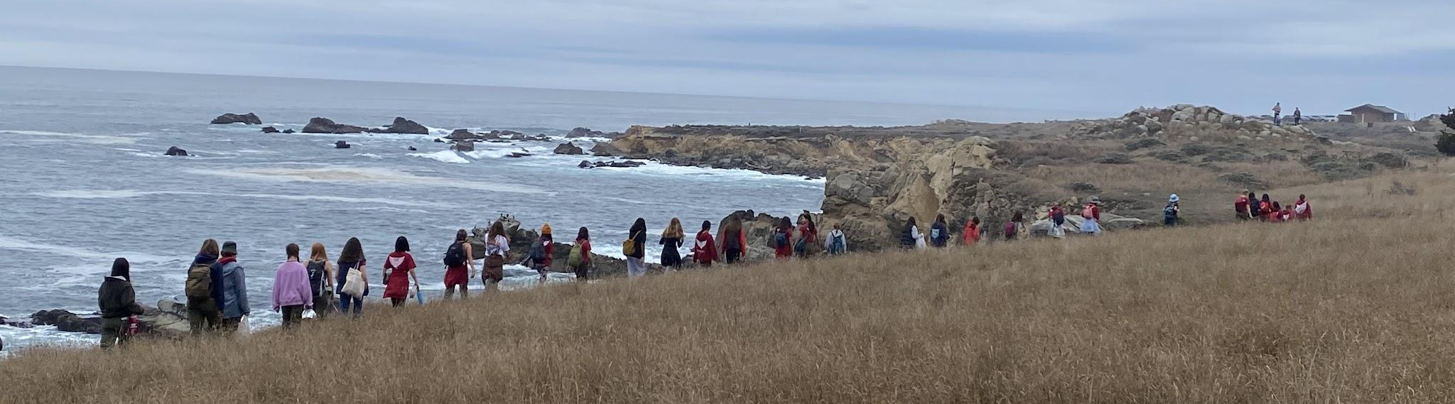

Troop 402 - All Scout Meeting Agenda

Meeting Theme: Swimming / Paddle Sports
Date: 9/9/2026
Time Slot | Activity Name and basic description | Designated Leader Group | who will teach/lead? | Activity detailed description of what is being done, how much time?
7:00 pm - MEETING SET UP & STEPS |  | ASMS |  | - Unlock Cabin  - Plug in Outdoor Lights  - Open Windows and Doors  - Bring out rolling carts for scouts,  - Work with Troop Guides to find materials needed for the meeting.  - Greet new interested parents and scouts - introduce them to troop guides and SPL.
 |  | TROOP GUIDES |  | Make sure all Materials for Skills Instructions are present
 |  | INSTRUCTORS |  | Set up stations for Skills Instructions Green, Blue, Black
 |  | ASPLS |  | Round Up Challenge Station
 |  | SPLS |  | Write Announcements on Board
 |  | ASMS |  | Set Up ASM/Troop Guide Table
7:00 - 7:15 | Pre-Opening | ATHENA PATROL |  | - KNOT BOARDS  - LASHING SAMPLES AND CARDS  - STEM GAMES/FIDGET STATION/QUIET AREA  - *Meeting Theme Specific Information set up
7:10 - 7:15 | Pre-Meeting with JLC | SPL team |  | ON STAGE: Meet with YLC Present to review meeting agenda
7:15-7:25 (10 Mins) | Opening | ATHENA PATROL |  | Flag Raising Ceremony - Class A
7:15-7:25 (10 Mins) | Opening | SPL team |  | Scout Oath and Law
7:15-7:25 (10 Mins) | Opening | ATHENA PATROL |  | Scout Skit or Song Scout Song Ideas, More Songs, Scout Skits
7:15-7:25 (10 Mins) | Opening | SPL team |  | Announcements:  - Berryessa THIS WEEKEND  - Lafayette Art and Wine cleanup: 9/20  - Personal Fitness MB opportunity: 9/27  - Mount Lassen: 10/10  - Celebrate new ranks of Scouts just finishing BOR
7:25 - 7:30 (5 Mins) | Group Instruction | SPL | Overnight Patrol Leader Planning Instructions | Announcement:  Preparation for upcoming Camping event  - Gear checkout - What gear is needed  - Menu planning - Meals needing to be planned  - Advancement opportunity focus event offers
7:30 - 7:50 Patrol Leaders spend time with their patrols/sister patrols (Ice Breakers, Patrol Games, Advancement checks, Event Planning) | Patrol Breakout | Patrol Leaders  SISTER PATROLS ARE AS FOLLOWS:  - Falcon / Tiki  - Honey Badger / Mustang  - Gator / Sun Bear  - Red Panda / Snow Leopard  - Hyena / Fox  - Senior Leadership - Athena Guides  - Instructor Patrol - Owls | ALL | Patrol Breakout Checklist:  BEFORE Meeting, check Troop Meeting Planner Band for Patrol Leader Details  - Grab Patrol Book!  - Take Attendance - Uniform Check and make a list of what scouts are missing so we can reorder for them. - Turn into Mrs. T  - Review Announcements - Answer Questions  - Upcoming Overnight Event Details  - Confirm Sign Up in your Patrol - Encourage Participation  - Ask about Tenting and who they wish to tent with - Make a note  - Create Duty Roster for Event  - Assign a Grubmaster (Scout to create Meal Plan on their own)  - Ask about Scout Rank Requirement Needs -  - Cooking especially for upcoming event  - Community Service Opportunities  - If our outing offers rank advancement for the requirements that are challenging to offer - Orienteering, hiking, swimming etc.. encourage participation.  - Ask Scouts if they have any questions or things you can help them with.  - Games / Ice Breakers / etc…
7:50 - 8:00 (10 Mins) | Group Instruction | SPL |  | Explain Skills being taught tonight - demonstrate or discuss overall importance of skill
 |  | Meeting Leadership Names |  | Requirements Covered
8:00 - 8:30 each Station 30 Mins. Each Station geared toward the appropriate rank level and skill for scouts to attend. Instructors and troop guides will choose their comfort level of the skill to teach using the resources of their experience / Merit Badges / Scoutbook | NEW SCOUT ORIENTATION | Troop Guides Present | Working on Scout Rank | Work with New Scouts that have not earned Scout Rank - Cover New Scout Orientation - Once a scout earns Scout Rank they move to the Green Skills Focus Station
 |  | Leadership Names |  | Requirements Covered-5a
 | Skills Instruction - Essential (Scout & Tenderfoot) - Teach the skills - end with a challenge or a game  20 Mins for skill & 10 for game or challenge | naina, Morgan | Working on Tenderfoot Requirements | Buddy System while Kayaking and Paddle Boarding  Troop Meeting Skills Station Instructions 9/9/2026 Swimming/Paddle Sports-Green  Instructions:  Explain what the buddy system is and why it is important. Teach the scouts the importance of the buddy system while kayaking, paddle boarding or just being in the water in general. You should connect the buddy system to the precautions for a safe swim.  Game: Blind Fold Obstacle Race  Materials: Bandana, things to act as obstacles like cups, cones, or anything that works during the setup.  Place:flag pole  Instructions:  Set up an obstacle course. Have the scouts find a buddy. One of them will be the navigator and the other will be blindfolded. The navigator will guide the blindfolded scout through the obstacle course only with their voice. If this does not take up enough time, you can rearrange the items to make the course harder, or say that they can not talk and only use claps to communicate (ex.1 clap means forward, 2 claps means stop, etc.).
 |  | Leadership Names |  | Requirements Covered-5a
 | Skills Instruction - Challenge (Second Class) - Teach the skills - end with a challenge or a game  20 Mins for skill & 10 for game or challenge | keira, Abby | Working on Second Class Requirements | Precautions for a Safe Swim  Troop Meeting Skills Station Instructions 9/92026 Swimming/Paddle Sports-Blue  Instructions:  Teach the 8 precautions for a safe swim. Talk about why we follow these rules and why they are important. Remember to connect what you are teaching them to how we use it at Lake Berryessa. You should also talk about how to find a safe area to swim, the different swim tests and how you get them.  1.Qualified Supervision- Lifeguard, 21 or older  2. Personal Health Review- Make sure you are not sick or injured, etc.  3. Safe Area- Clean water, no hazards  4. Response Personnel- Lifeguards  5. Lookout- A place where the lifeguard has a view of everyone.  6. Ability Groups- What swim test a scout has passed (nonswimmer, beginner-BSA beginner test, swimmer-BSA swimmer test)  7.Buddy System-Always have a buddy  8.Discipline- Respect the rules and follow instructions from lifeguards and adult leaders  Game: Safe Swim Matching  Materials:8 slips of paper with the 8 principles written on them, scenario sheets (if you want)  Place: trees  Instructions:  Lay out the 8 slips of paper. The leader of the station will read out the scenario on the scenario sheet (or just make a scenario up) and the scouts will go to the principle it lines up with. For example, the leader could say “A lifeguard sits in an elevated seat that has a view of the whole lake”, then the scouts go to the slip that says lookout because that is what the scenario is describing. If you want, you could create scenarios that violate a principle, and the scouts have to go to the principle it violates.
 |  | Leadership Names |  | Requirements Covered-6c, 6d
 | Skills Instruction - Advanced(First Class) - Teach the skills - end with a challenge or a game  20 Mins for skill & 10 for game or challenge | Aya, Calista | Working on First Class Requirements | Parts of a Kayak and a Paddle and Proper Body Positioning in a Water Craft:  Troop Meeting Skills Station Instructions 9/9/2026 Swimming/Paddle Sports-Black  Instructions:  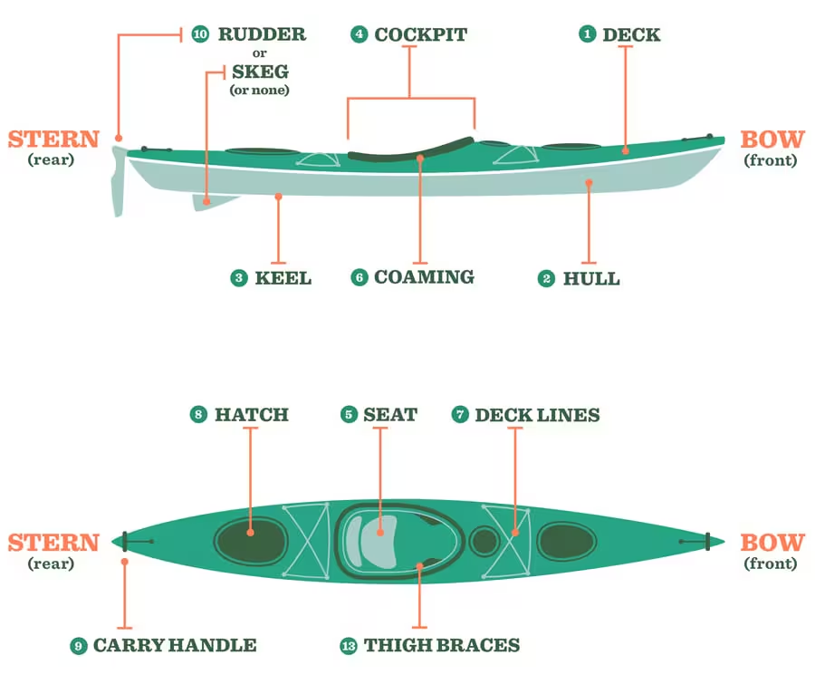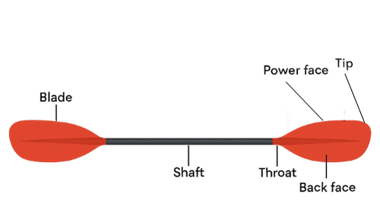  Teach the scouts the main parts of kayak and paddle. Some important things to cover are, the stern and bow, port, starboard, amidship, and all the things in the diagram. Explain what we will be using the kayak for during the next campout. Teach the scouts the main parts of a paddle (Grip, shaft, throat, blade, and tip). Talk about how to hold and use a paddle, and what we will be using it for during the next campout. Explain how to properly position yourself in a kayak and what happens if you do not do so.  Game: Kayak Simon Says  Place: inside the cabin  Materials: nothing  Instructions:  Label the walls in a room (or an area if you are outside) the stern (Back of the room), the bow (front of the room), the starboard (right side of the room), and the port (left side of the room). Like regular Simon says, just to areas of the room (ex. Simon says go to starboard, the scouts would go to the right side of the room). You can also include other things like show how to sit in a kayak, or just random things to make it harder (ex. Simon says go to starboard and create a group of 3 and do a first aid carry).
8:30 - 8:40 | Clean up Stations | All Scouts |  | Help to clean up cabin and put away station materials
8:40 - 8:45 | Closing Ceremony | SPL |  | Review Summary of Announcements & reminders, SM Minute  - Berryessa THIS WEEKEND  - Lafayette Art and Wine cleanup: 9/20  - Personal Fitness MB opportunity: 9/27  - Mount Lassen: 10/10
8:45 - 8:55 | Troop Meeting Review Update Adult Leadership regarding any scout issues | SPL Team

